SQL INDEX

✅ Purpose:
# Source: AI Source: Provided by: [Data Path: Persons Table -> ID Column: 1, Name_En Column: Motasem Essam] -> From: [ChatGPT] on [6/11/2026]
SHOW INDEX (or SHOW INDEXES / SHOW KEYS) displays details about the indexes defined on a table. This is helpful for analyzing query performance and understanding how data is accessed efficiently.

📘 What is an Index in SQL?

🔍 Definition:
# Source: AI Source: Provided by: [Data Path: Persons Table -> ID Column: 1, Name_En Column: Motasem Essam] -> From: [ChatGPT] on [6/11/2026]
An index in SQL is a performance optimization structure that allows faster retrieval of rows from a table, similar to an index in a book. Instead of scanning every row, MySQL can quickly jump to the rows using the index.

📦 Think of it like:
# Source: AI Source: Provided by: [Data Path: Persons Table -> ID Column: 1, Name_En Column: Motasem Essam] -> From: [ChatGPT] on [6/11/2026]
Imagine a phone book:
- Without index: You search every name line by line.
- With index: You jump straight to the letter "S" to find "Smith".

✅ Why Use Indexes?
# Source: AI Source: Provided by: [Data Path: Persons Table -> ID Column: 1, Name_En Column: Motasem Essam] -> From: [ChatGPT] on [6/11/2026]
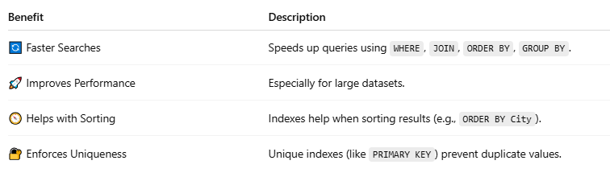
Benefit | Description
🔄 Faster Searches | Speeds up queries using WHERE, JOIN, ORDER BY, GROUP BY.
🚀 Improves Performance | Especially for large datasets.
🧭 Helps with Sorting | Indexes help when sorting results (e.g., ORDER BY City).
🔐 Enforces Uniqueness | Unique indexes (like PRIMARY KEY) prevent duplicate values.

🧱 Types of Indexes in MySQL:
# Source: AI Source: Provided by: [Data Path: Persons Table -> ID Column: 1, Name_En Column: Motasem Essam] -> From: [ChatGPT] on [6/11/2026]
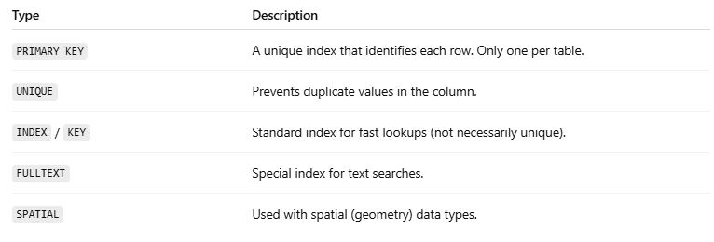
Type | Description
PRIMARY KEY | A unique index that identifies each row. Only one per table.
UNIQUE | Prevents duplicate values in the column.
INDEX / KEY | Standard index for fast lookups (not necessarily unique).
FULLTEXT | Special index for text searches.
SPATIAL | Used with spatial (geometry) data types.

💡 Example:
# Source: AI Source: Provided by: [Data Path: Persons Table -> ID Column: 1, Name_En Column: Motasem Essam] -> From: [ChatGPT] on [6/11/2026]
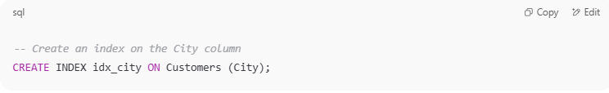
-- Create an index on the City column
CREATE INDEX idx_city ON Customers (City);
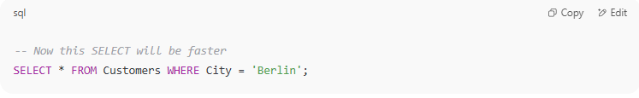

-- Now this SELECT will be faster
SELECT * FROM Customers WHERE City = 'Berlin';

⚠️ Notes:
# Source: AI Source: Provided by: [Data Path: Persons Table -> ID Column: 1, Name_En Column: Motasem Essam] -> From: [ChatGPT] on [6/11/2026]
- Indexes speed up reads but can slow down writes (INSERT/UPDATE/DELETE) because they must update the index.
- Use indexes wisely: too many indexes = wasted space + slow updates.

📌 Syntax:
# Source: AI Source: Provided by: [Data Path: Persons Table -> ID Column: 1, Name_En Column: Motasem Essam] -> From: [ChatGPT] on [6/11/2026]
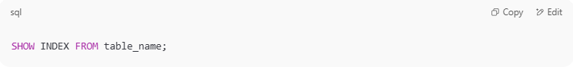
SHOW INDEX FROM table_name;

Or (optional):
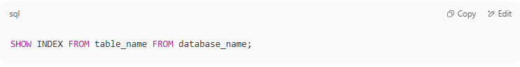
SHOW INDEX FROM table_name FROM database_name;

📊 Example:
# Source: AI Source: Provided by: [Data Path: Persons Table -> ID Column: 1, Name_En Column: Motasem Essam] -> From: [ChatGPT] on [6/11/2026]
Let's say we have a table:
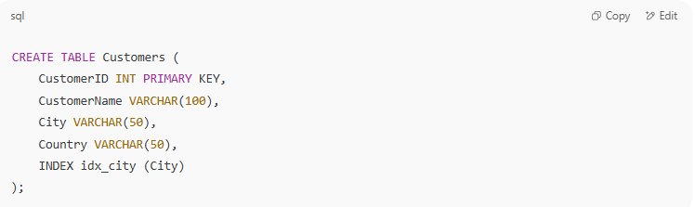
CREATE TABLE Customers (
CustomerID INT PRIMARY KEY,
CustomerName VARCHAR(100),
City VARCHAR(50),
Country VARCHAR(50),
INDEX idx_city (City)
);

Now, run:
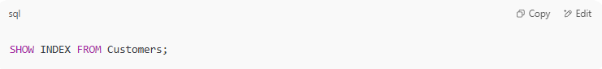
SHOW INDEX FROM Customers;

📋 Typical Output Columns Explained:
# Source: AI Source: Provided by: [Data Path: Persons Table -> ID Column: 1, Name_En Column: Motasem Essam] -> From: [ChatGPT] on [6/11/2026]
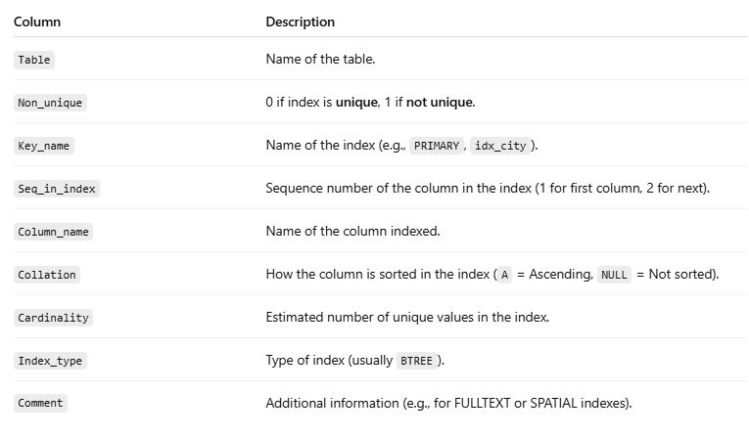
Column | Description
Table | Name of the table.
Non_unique | 0 if index is unique, 1 if not unique.
Key_name | Name of the index (e.g., PRIMARY, idx_city).
Seq_in_index | Sequence number of the column in the index (1 for first column, 2 for next).
Column_name | Name of the column indexed.
Collation | How the column is sorted in the index (A = Ascending, NULL = Not sorted).
Cardinality | Estimated number of unique values in the index.
Index_type | Type of index (usually BTREE).
Comment | Additional information (e.g., for FULLTEXT or SPATIAL indexes).

🧠 Why It Matters:
# Source: AI Source: Provided by: [Data Path: Persons Table -> ID Column: 1, Name_En Column: Motasem Essam] -> From: [ChatGPT] on [6/11/2026]
- Helps determine if the right indexes exist to optimize queries.
- Helps identify missing or redundant indexes.
- Useful when debugging slow queries or tuning performance.

🔐 Related Commands:
# Source: AI Source: Provided by: [Data Path: Persons Table -> ID Column: 1, Name_En Column: Motasem Essam] -> From: [ChatGPT] on [6/11/2026]
- SHOW CREATE TABLE table_name; — shows index definitions too.
- EXPLAIN SELECT ... — shows which indexes are used during a query.

Example 1

prepared commands
# Source: ScreenShot Source: Provided by: [Persons Table -> ID Column: 1, Name_En Column: Motasem Essam] -> Tool: [Automation Table -> ID Column: 16, Name_En Column: Screen Capture] -> From [Operating System: Wampserver64 -> phpmyadmin] on [6/11/2026]
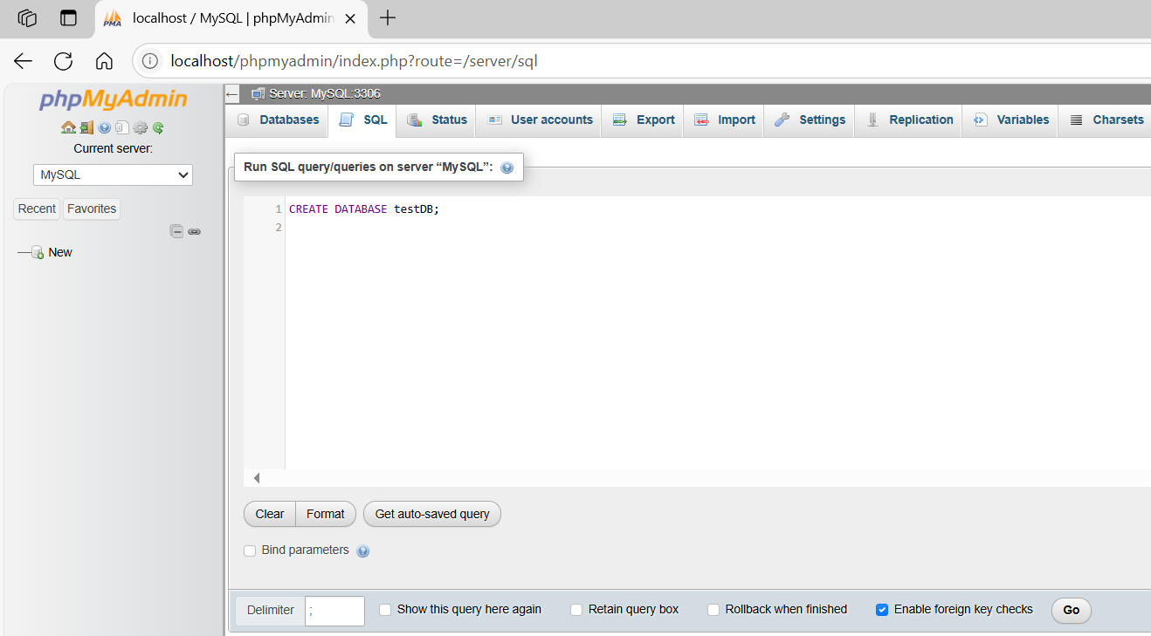
CREATE DATABASE testDB;
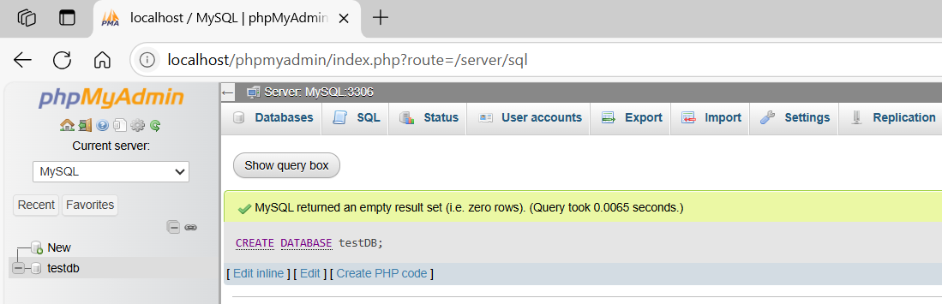
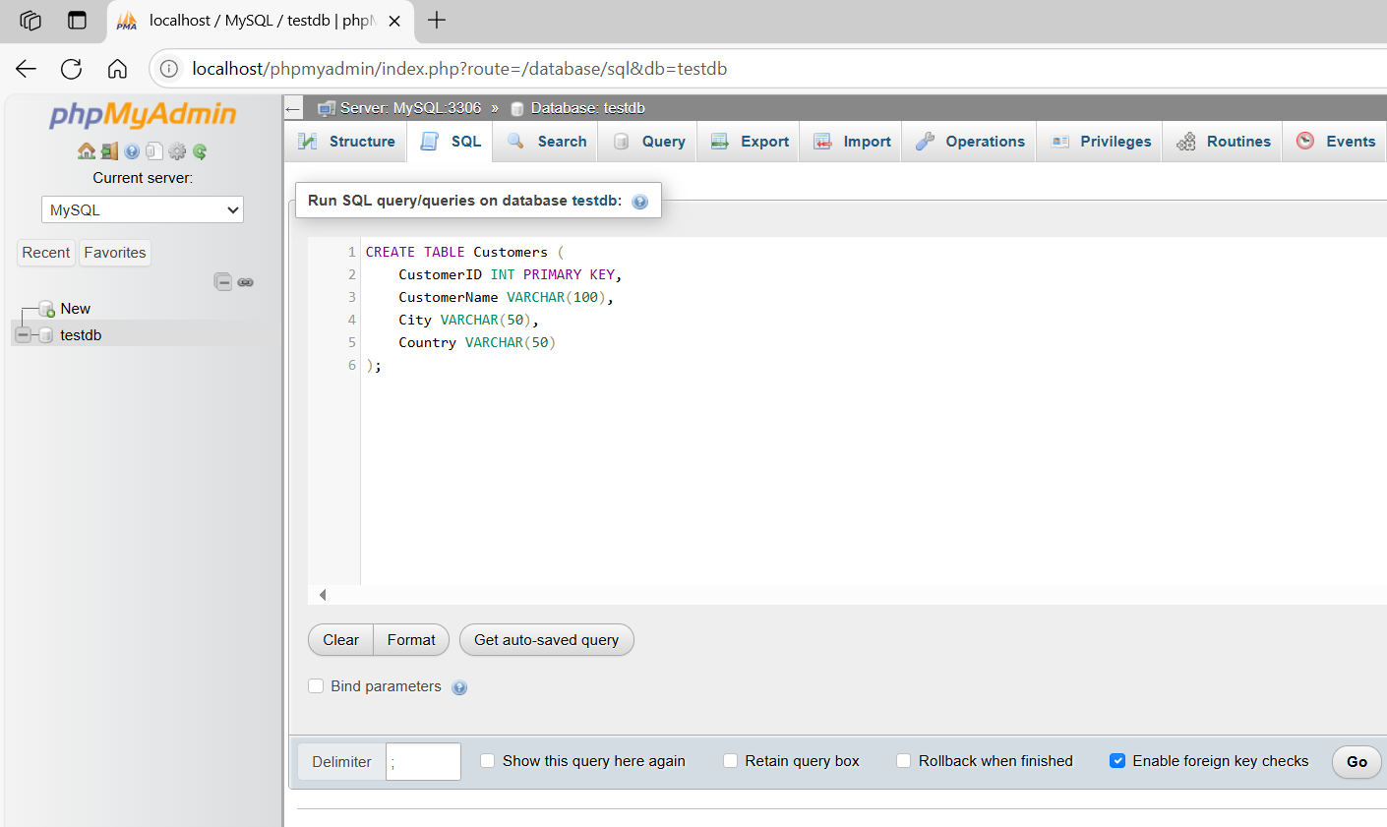
CREATE TABLE Customers (
CustomerID INT PRIMARY KEY,
CustomerName VARCHAR(100),
City VARCHAR(50),
Country VARCHAR(50)
);
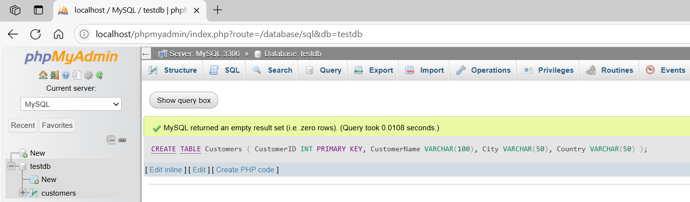
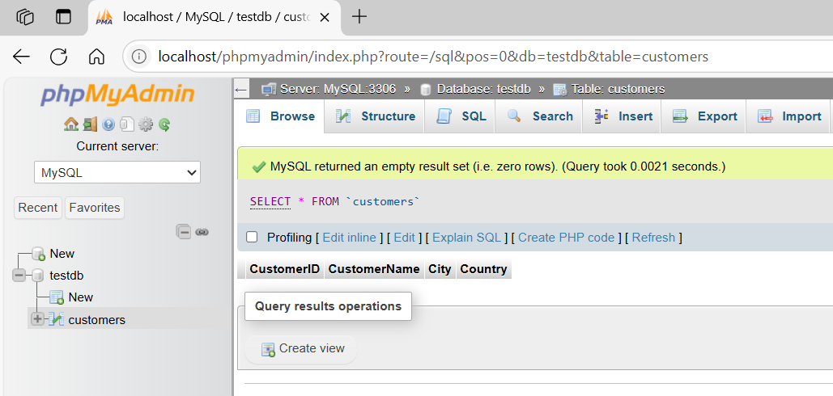
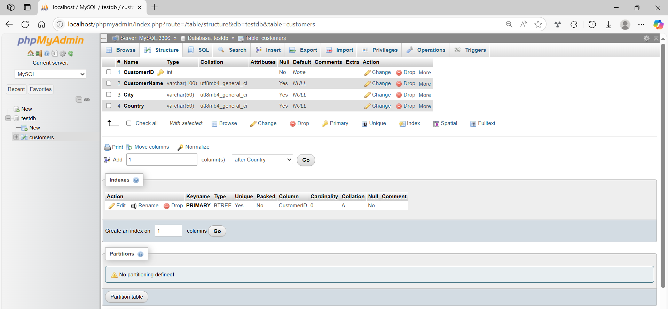

basic command
# Source: ScreenShot Source: Provided by: [Persons Table -> ID Column: 1, Name_En Column: Motasem Essam] -> Tool: [Automation Table -> ID Column: 16, Name_En Column: Screen Capture] -> From [Operating System: Wampserver64 -> phpmyadmin] on [6/11/2026]
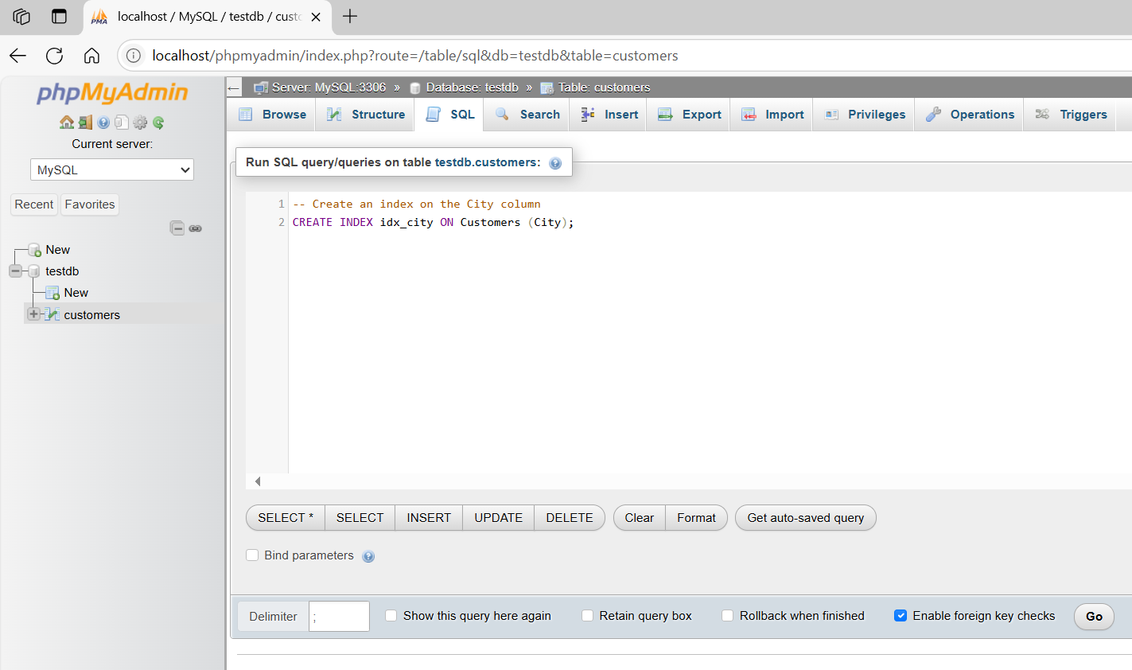
-- Create an index on the City column
CREATE INDEX idx_city ON Customers (City);
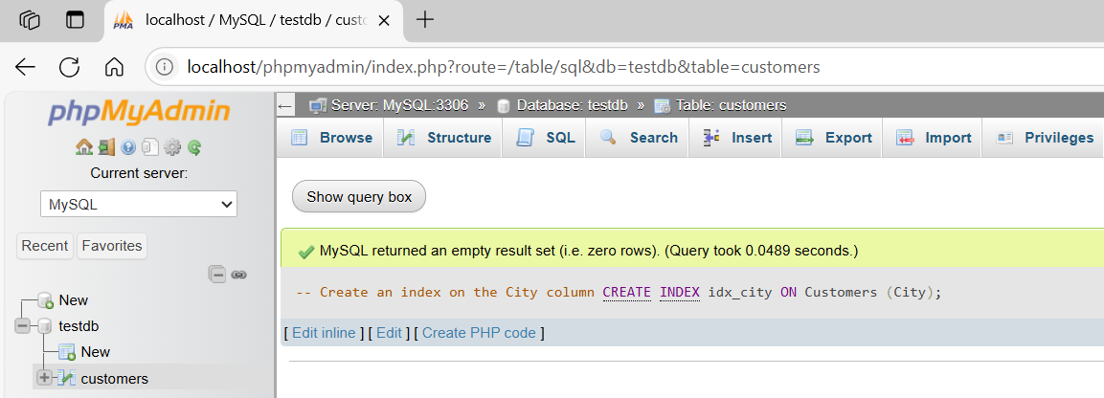

Example 2

prepared commands
# Source: ScreenShot Source: Provided by: [Persons Table -> ID Column: 1, Name_En Column: Motasem Essam] -> Tool: [Automation Table -> ID Column: 16, Name_En Column: Screen Capture] -> From [Operating System: Wampserver64 -> phpmyadmin] on [6/11/2026]

CREATE DATABASE testDB;


basic command
# Source: ScreenShot Source: Provided by: [Persons Table -> ID Column: 1, Name_En Column: Motasem Essam] -> Tool: [Automation Table -> ID Column: 16, Name_En Column: Screen Capture] -> From [Operating System: Wampserver64 -> phpmyadmin] on [6/11/2026]
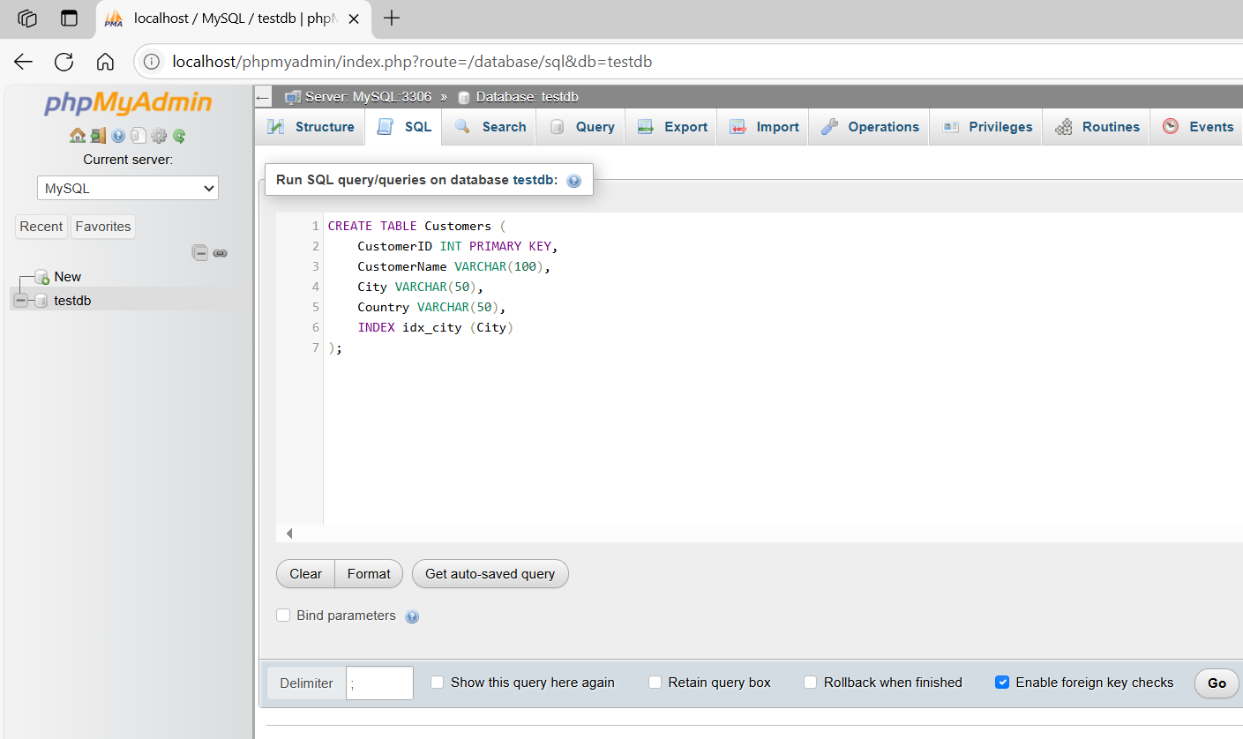
CREATE TABLE Customers (
CustomerID INT PRIMARY KEY,
CustomerName VARCHAR(100),
City VARCHAR(50),
Country VARCHAR(50),
INDEX idx_city (City)
);
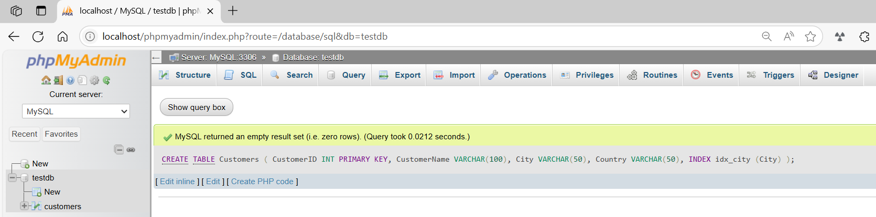
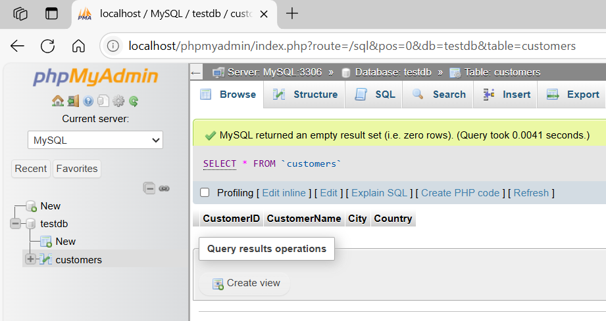
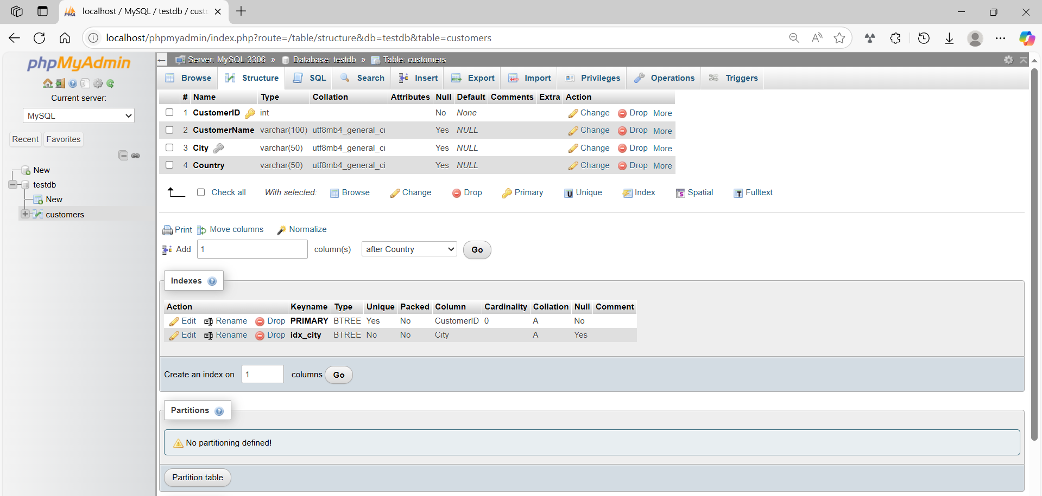

basic command
# Source: ScreenShot Source: Provided by: [Persons Table -> ID Column: 1, Name_En Column: Motasem Essam] -> Tool: [Automation Table -> ID Column: 16, Name_En Column: Screen Capture] -> From [Operating System: Wampserver64 -> phpmyadmin] on [6/11/2026]
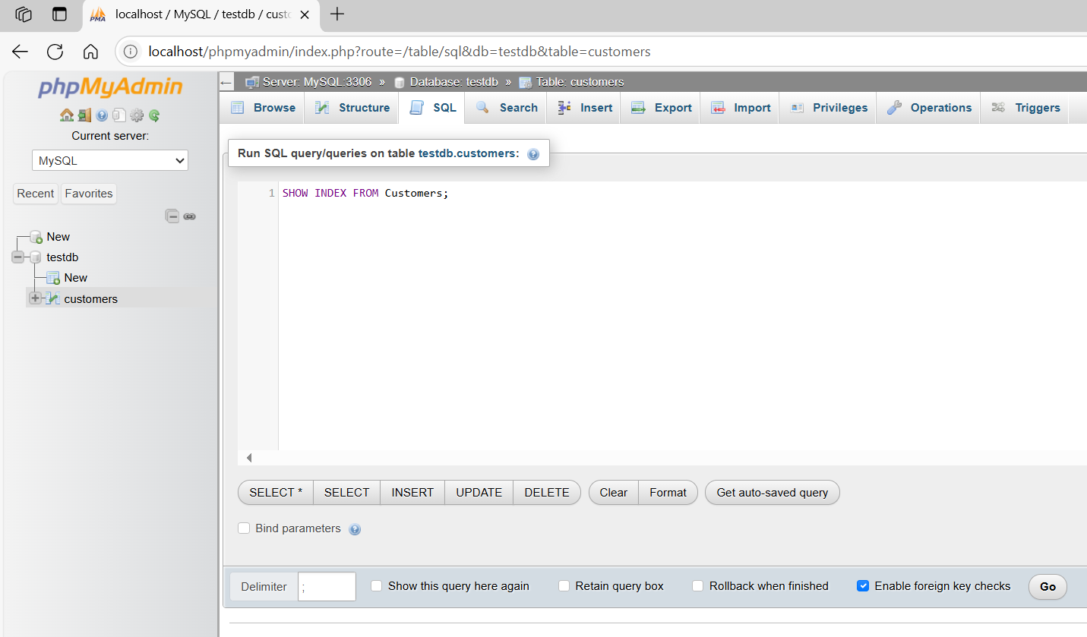
SHOW INDEX FROM Customers;
